Aesthetics of Human Suffering in Crisis Images: An Analysis of Selected Visuals in News Media, NGO Campaigns, and Social Media

Abstract
This study comparatively analyses how crisis images construct meanings of human suffering, dignity, vulnerability, and humanitarian urgency. It uses a purposive sample of 17 visual materials that have been circulating over a period of 10-20 years in news media, NGO campaigns and social media, and employs qualitative visual analysis of composition, framing, colour and camera distance complemented by Barthesian semiotics and contextual analysis. The framework is based on Sontag, Said, McLuhan, Meis and Baudrillard. Analysis reveals that children and women are "ideal victims"; close-up and wide-shot distances have divergent viewer–subject relations; desaturated palettes convey urgency, warmer palettes convey dignity or resilience; and, the medium itself conditions meaning. It provides a comparative, production-oriented analysis of humanitarian imagery in three institutional settings that will benefit journalists, NGOs, and students of visual culture.
Keywords: humanitarian imagery; visual semiotics; crisis photography; NGO campaigns; media aesthetics

Chapter 1
Introduction
Images have become an important way of learning about war, forced displacement, poverty, famine, natural disasters, and other humanitarian issues. News organisations, NGOs and social media users regularly publish photographs and campaign images of unsafe and difficult living conditions. The image of Alan Kurdi, for instance, was linked to the Syrian refugee crisis, and the image of Omran Daqneesh was that of a child suffering as a result of the Syrian conflict. The case studies illustrate how crisis images not only provide documentation of crisis events, but also help to create understandings and memories of such crises. This paper explores the representation of suffering and vulnerability as portrayed in images from news media, NGOs and social media, in terms of the visual and contextual components of such images.
Crisis images” are images of people who are impacted by humanitarian crises, such as photographs, campaign images or social media images. The chosen photographs are on the themes of war, displacement, poverty, famine and other human suffering. This definition is meant to structure the materials for analysis and does not mean all the images of crisis have the same meaning or that they are objectively suffering. Furthermore, the sense of an image is also influenced by the institution and platform that produce and circulate the image. Images are mostly used by news organisations for reporting and documentation purposes, while NGOs use them for awareness creation, advocacy, fundraising and public communication. Social media exists in another world, where images can be quickly transferred, out of context, and interpreted by a variety of audiences. Thus, the visual content, or message, of the same object can yield varying meaning according to its context, place and manner of presentation. Photographs are not necessarily considered an unbiased reflection of reality because photographers, editors, organizations or platforms determine who and what will be depicted, when, where, and how, as well as what will be omitted. Human suffering is also portrayed in the ethical, religious, racial and cultural aspects.
In crisis images, often the centre is children and women, portrayed as ‘Idle Victim’ (Ongenaert & Soler, 2024). Similarly, refugees and displaced persons tend to be depicted as innocent and helpless. However, over time these can turn people into passive victims and their dignity, identity and agency fade from view. The images of non-Western peoples may also indicate imbalanced relationships of power between the depicted and the viewer. In certain campaigns, the use of religious symbols, languages, food, clothing and mention of Ramadan are used to create a connection with a specific audience. These decisions might clarify a message to one audience and have varying meanings to viewers from other cultural or religious backgrounds. The meaning of visual representations is therefore assumed in this study to be non-universal and the image of crisis to have a social, cultural and ideologically bias.
Previous studies have examined humanitarian photography, visual framing, NGO communication, and digital circulation. But the news media, NGOs and social media have been studied separately. The aim of this study is to fill this gap by comparing the constructions of meaning on suffering with selected crisis images in different media contexts. The question is especially salient in the digital era, when the very same photo might be used in a news article, for an NGO campaign, or in a social media post, and be perceived differently in each case. Humanitarian crises are typically depicted to the public via emotional and dramatic images, with the processes and impacts of such image construction being less critically examined.
The study focuses on the visual aspects of images, as well as cultural and symbolic content, and institutional and platform contexts, where images are displayed. It's not about the viewer, but about the images portraying suffering, vulnerability, dignity, hope and urgency. The study analyses the process of constructing crisis images and the meanings and values they convey. This study explores the ways in which visual and aesthetic choices such as composition, colour, lighting, framing, camera distance, symbolism, the use of written language and the context of the platform lead to the representation of human suffering in images of crises. The study aims to elucidate the visual representation of human suffering and the ethical concerns it can raise, through the examination of these elements.
Research Problem
Crisis images are spread throughout media contexts, but their visual construction and meaning-making of suffering must be further explored. They are not just about recording events, they are selected, cut, put together, described and shown in defined institutional and media contexts. Therefore, the significance of suffering can be different depending on the style, use and platform of an image.
Crisis images are used for various reasons by different news media, NGOs and social media. News outlets can report on events, NGOs can publicize and fund-raise, and social media can spread pictures quickly, out of context. These differences influence perceptions of suffering, vulnerability, dignity, sense of urgency, and responsibility. While the images in a crisis may evoke empathy and humanitarian concern (Chouliaraki & Stupart, 2025), the response of the audience is not measured, and it depends on their cultural, political and personal context. Rather, it explores the ways in which images and institutional settings produce meaning of suffering.
Studies have been conducted on humanitarian photography and representation of refugees. Fehrenbach & Rodogno (2015) provides an analysis of the history of suffering images in humanitarian communication, while Ongenaert & Soler (2024) provides an analysis of refugee imagery on social media. But research is scarce that directly compares these three actors, the news media, NGOs, and social media, let alone when they tackle the same crisis. An advocacy image and a news photo of the same event may vary in the composition, the framing, the distance of the camera, the caption and the emphasis. This study aims to fill this gap by looking at the context and purpose of institutions and platforms in creating visual depictions of suffering.
The research starts with some selected crisis images, which in the recent Gaza conflict have been diffused in social media. It questions if “new” images are simply repetitions of “old” visual strategies or if they are new ways of representing. The analytical framework for the analysis of the construction of vulnerability, dignity, urgency and responsibility is composition, colour, lighting, framing, camera distance, typography, symbolism and platform context.
Research Questions
- How do visual and aesthetic elements such as composition, framing, lighting, color, focus, camera distance, typography, and symbolism construct meanings of human suffering in selected crisis images?
- How do news media visuals, NGO campaigns, and social media images use different visual and contextual strategies to represent suffering, vulnerability, dignity, hope, and humanitarian urgency?
- What ethical, cultural, racial and religious questions arise out the aesthetic depiction of human suffering in crisis images?
Objectives of the Study
- To examine how meanings of human suffering are conveyed in selected crisis images through the use of visual and aesthetic elements (composition, framing, colour, lighting, camera distance, typography and symbolism) and the context of a platform.
- To analyse the representation of suffering, vulnerability, dignity, hope and humanitarian urgency in news media images, NGO campaign images and social media images, and how this varies according to their institutional goals and media contexts.
- To understand the moral, cultural, racial and religious issues that arise from images depicting human suffering in crisis and the aesthetic representation of that suffering.
Significance of the Study
Humanitarian images are significant in providing the public with its conception of global crises such as war, poverty, displacement and natural disasters. The significance of the study of these images lies in the fact that it is possible to see how visual construction, aesthetic considerations, images, and media practice produce meaning about human suffering. This research helps to understand the effect of the visual elements on the depiction of humanitarian crises. It illustrates how the meaning is determined by framing, colour, composition and symbolism, and it draws attention to ethical issues of dignity, and representation. Moreover, making comparisons between the images created and disseminated by different media institutions, the research gives insight into the differences in humanitarian communication and adds to the field of media studies, visual culture, and humanitarian communication.
Scope and Limitations
Scope:
This study considers the visual representations of human suffering in selected humanitarian images generated and/or broadcasted by the mainstream news media, NGOs and photojournalists. It discusses framing, composition, colour, perspective, lighting, symbolism and photographic technique, and the ethical and aesthetic dimensions of photographing humanitarian situations.
The study concentrates mainly on visual materials of the last decade or so, and uses Western and non-Western case studies to explore current visual practices. It is not all-encompassing when it comes to humanitarian media, but rather a selection of cases which would be suitable for qualitative content analysis.
The effectiveness and credibility of humanitarian organisations or media institutions is not examined. It highlights the depiction of crises in these institutions by means of images. As such, insights gained from it are specific to the materials studied and may not be applicable to other humanitarian media or modes of visual communication. These boundaries help to ensure focus and that the study is consistent with its qualitative approach and theoretical framework.
Limitations of the Study
In this study, the emphasis is placed upon visual construction of the humanitarian images, rather than on audience reception. It does not investigate how viewers interpret images or how they might affect viewers' emotions, psychology or behaviour. Therefore, audience surveys, interviews, or other analysis of audience response is not included in the research, and the focus is on the ways in which visual and contextual aspects of the film influence the portrayal of suffering.
As interpretations may differ in different cultural, social and personal context, the study will use a content-based approach to the images selected. Also, because of time and resources, the number of images analyzed is limited. Furthermore, some of the humanitarian images may not have detailed background data for analysis, which limits the context. While visual analysis can help to convey key meanings, it cannot adequately convey the political, historical, and social complexities of each crisis.

Chapter 2
Literature Review
Humanitarian images have been a focus of study in part due to their capacity to make distant suffering visible, and to make viewers of the images feel connected to the suffering. Initial research primarily centred on the capacity of war, famine and disasters images to garner public interest and prompt humanitarian action. But it was later contended that such images are not unbiased representations of reality. Visual decisions and emotional appeals, combined with a social environment of image production and dissemination, have a great impact on the meaning of humanitarian images.
2.1 The Power of Humanitarian Images: Emotion, Appeals and Iconic Photographs
As described by Fehrenbach and Rodogno (2015), humanitarian photographs have always been tools for bridging distant audiences with people who are affected by a crisis. By employing images of suffering, humanitarian agencies and media outlets aim to elicit sympathy, empathy and publicity. Ideas like that, Bayram and Holmes (2021) delve into the idea that shining a light on the individual victim creates a more emotional response than depicting a large group of people affected. They have found that pictures of recognizable people can help viewers to feel closer to the victims and more inclined to help.
But this emotional approach also has representation and power issues. Ongenaert and Soler (2024) describe how women and children are frequently portrayed as vulnerable targets in digital humanitarian communication, due to their potential to elicit emotional response. Such depictions can raise awareness and aid money, but they can also single out the individual victim of the crisis and streamline the problem, emphasizing primarily on the suffering of the individual and not so much on the social and political issues.
Negative appeals, portraying images of suffering to grab attention and inspire action, are an important form of emotional appeal in humanitarian communication. These pictures, also sometimes known as "negative appeals," that meant to catch the public's eye and force the public to take action, since there's a lot of news and information available all over the place. Such images can make people experience strong emotions and motivate them to help in the short term (Bayram & Holmes, 2021). Historically, humanitarian photography has been deliberately showing suffering in order to provoke sympathy, empathy or even guilt, in an attempt to control public opinion as well as generate money (Fehrenbach & Rodogno, 2015)ng photographs of the Ethiopian famine of the 1980s with severely starving children moved a lot of people to donate. However, there are serious ethical questions in using such shocking images. Critics worry that being exposed to very shocking pictures all the time can result in so-called "compassion fatigue," or make people feel overwhelmed and less sensitive over the time. This strategy is also criticized for "poverty porn," in which images may take advantage of the hard situations of people in need. These pictures often include the helpless victims, especially women and children, to create a sense of pity and guilt (Bellander, 2021). This could help to attract donations, but it is dehumanizing the individuals displayed. It also takes complex problems and simplifies them, so that viewers focus on the individual in distress and not the overall issue of why a crisis has occurred. Organizations must consider the need to provide support urgently and in an ethical way that does not involve manipulating the emotions of individuals.
Some humanitarian images are more than just a fleeting flash in the pan and they become iconic for specific crises and draw attention to them. Some of the images from humanitarian crises become just plain unforgettable. These "iconic photographs" have the ability to capture one powerful moment that grabs the attention of the world. They are like a rapid visual summary of complicated problems which brings distant suffering into the present and makes it personal. Such images often provoke great feelings, such as empathy or shook, which in turn can make people want to help. For instance, the image of three-year-old Aylan Kurdi whose body was taken to shore in 2015 was soon a worldwide image of the refugee crisis. This image brought much needed attention to the war in Syria and the plight of its victims (Fehrenbach & Rodogno, 2015; Slovic et al., 2017) these iconic photographs has important limits as well. While they can be responsible for a powerful emotional response, this feeling often isn't there for long. “woke the world for a brief time, bringing much-needed attention to the war and the plight of its many victims. But this empathic response was short-lived. We outline the need for better laws, institutions, and decision-making procedures…” (Slovic et al., 2017). The immediate wave of empathy may be "short-lived" and the public interest may soon lapse as new events overtake the news cycle. This is sometimes referred to as the "ebb and flow of empathic response." Moreover, by concentrating on one dramatic moment, these images sometimes reduce very complex situations to a simple level. They might describe the individual suffering without explaining the underlying political, social or economic causes of the crisis. This can result in a limited understanding of the problem and in boiling complex issues down to personal tragedies (Pruce, 2016). For instance, pictures of starving Biafra children in the late 60s were effective at raising awareness about the situation, but at the same time they were criticised for being shown in the context of the affected regions without providing enough context, and for potentially reinforcing stereotypical images (Fehrenbach & Rodogno, 2015). In conclusion, iconic images can be effective in raising awareness, but they need to be complemented by more comprehensive campaigns that foster long-term learning and action. In this regard, iconic humanitarian photographs can help to inform public opinion, and their emotional impact needs to be contextualized to their disadvantages in the representation of complex situations.
2.2 Visual Construction of Suffering: Framing and Aesthetic Strategies
Images of suffering, in other words, are not just aspects of the humanitarian, but are also ways to understand crises. An image's composition, frame and perspective are ways of shaping viewers' interpretation of the victims and their experience. The visual options can generate the sense of proximity, distance, vulnerability or responsibility in audiences. Visual images are important in shaping a humanitarian experience. With a close up portrait, it can be easier to relate since they're only seeing someone's story. Group images, however, can represent the scale of a crisis, but also individual people as members of a group (Bellander, 2021; Ongenaert & Soler, 2024). Interpretation is impacted by the camera angle. Eye-level perspectives can make the victims seem like equals and evoke closeness, whereas high-angle shots can highlight vulnerability and powerlessness (Ongenaert & Soler, 2024). In Facebook or Instagram posts of UNHCR about the situation of Syrians and Ukrainians, the commonly use of eye-level angles for a sense showing closeness and bird's eye view for emphasis on their vulnerability.
Humane images typically use consistent visual elements to evoke vulnerability, besides composition. Kids are usually portrayed, as their innocence and helplessness can elicit strong emotional responses from viewers. This can also limit the representation of complex crisis situations to a 'victimology' view, where the focus is on the vulnerability of the victims (Chouliaraki & Stupart, 2025; Jhoti & Allen, 2024; Ongenaert & Soler, 2024).
Humanitarian images are also understood in regard to aesthetic elements like colour, lighting, focus, typography and symbolism. The colors may express different emotions, such as darker tones, for suffering; and hotter tones, for hope and resilience. Focus can be used to draw attention to specific faces or to general crisis situations (Belinskyi et al., 2023). Iconic photographs, usually recognized for their dynamic visual composition and use of color, are known to highly inspire emotions and alter the perspective of the viewers (Slovic et al., 2017). For example, in media with often use black and white photo to display the poverty and the suffering which use the desaturated tones and the sharp contrasts to showing the timelessness of desperation which intensifies the urgency of the aid appeals (Bellander, 2021; Ongenaert & Soler, 2024). Together, all of these elements form a powerful visual language. It helps increase humanitarian appeals by creating the feelings of empathy and support. Typography and Symbols are also means of communication in humanitarian campaigns, which emphasize the importance of the message and encourage a response from the audience (Sukma et al., 2022; Bellander, 2021). For example, in humanitarian appeals, "Donate Now" buttons typeface in websites and campaigns are frequently made with large, bold typography with high-contrast colors; often bright red or white against a dark background to grab attention, imply urgency as well as push people to donate immediately. Likewise, symbols in humanitarian images can be employed to summarize broader concepts and attitudes, and to effectively convey ideas in a concise way (Bellander, 2021). If well chosen, these elements can contribute to the overall appearance and emotion of humanitarian appeals and will influence the public's perception and reaction. The combination of these elements, from the power of color and the fine details of typography and symbolism, together form a coherent visual narrative, additionally influencing the perception and mobilization of the public towards humanitarian causes.
Aesthetic decisions are more than demonstrations of facts. They change perceptions and attitudes towards crises that occur in distant places (Ongenaert & Soler, 2024). According to Chouliaraki (2013), humanitarian communication can be carried out in three ways; the "shock effect", "positive style" and "post-humanitarian" approaches. The shock effect is based on conveying images of suffering, which evoke strong emotional responses; the positive style images portray people affected with greater dignity and agency. Post-humanitarian approaches not only involve emotional connection but also more sophisticated ways to be represented (particularly digitally). UNHCR's Instagram for refugees from Syria and Ukraine uses eye level shots of families to make a personal connection, not to elicit sympathy. These types of selections humanize those afflicted, and assist them in the long term. The picture of a drowned child, Aylan Kurdi, in 2015, which was taken on a Turkish beach, was widespread on the Internet and has brought the problem of the dangers of being a refugee to the world's attention again (Fehrenbach & Rodogno, 2015). How the compositional elements used inside an image are aesthetically pleasing, has a major effect on how the image is interpreted. The practice of composition also aids in meaning-direction. Close shots are shots that individualize, which clasp the viewer into common humanity. Group images do not run the risk of depersonalization. Detailed backgrounds, which include truthfulness and emotional pull. Bellander (2021) poses and indicates danger or resilience to overcome distance between audiences.
Overall, visual framing and aesthetic means are significant for the production of meaning of humanitarian sufferings. Images have the potential to provoke empathy and call for public discourse through a choice of composition, perspective and design. But the same choices can also shape the representation of the victim and can flatten out complicated crises into emotional stories.
2.3 Ethics, Representation and Effects of Humanitarian Images
There are a number of ethical issues of representation and power associated with humanitarian images. Some images can be used to increase suffering, perpetuate stereotypes, and portray people who have been affected primarily in their vulnerable state, rather than in their full social and political context (Bayram & Holmes, 2021; Mäenpää, 2023; Massari, 2021; Pruce, 2016).
In the picture, the Vulture and the Little Girl, a small, willing child sits on the ground, and a vulture is in the background behind her. The composition has an element that creates a path between the bird and the child. This creates a disturbing relationship in the frame. The iconic case in point is Kevin Carter's image Vulture and the Little Girl, which brought out extreme emotional reaction by juxtaposing the little girl and the vulture in an uneasy relationship. The photograph sparked ethical discussion on the possibility of giving more importance to the visual impact of the photo than to the dignity and agency of the people portrayed (Fehrenbach & Rodogno, 2015; Pruce, 2016).
These debates have inspired humanitarian groups to abandon images of helplessness and suffering. Pictures that showcase refugees and crisis-affected people in a dignifying way can make audiences think of them as partners, not just as aid recipients (Bellander, 2021). But aesthetic decisions can also obscure structural triggers of crises and put a distance between viewers and impacted communities (Ongenaert & Soler, 2024). Humanitarian images also shape the audiences' psychological reactions. Personal and emotional images can evoke sympathy and motivate to take humanitarian action; repeated exposure to suffering can cause ‘compassion fatigue' and viewers become less sensitive (Ongenaert & Soler, 2024). Bayram and Holmes (2021) also note that emotional reactions to a situation, including pity and empathy, can lead to support, yet can also lead to disengaging after repeated exposure.
Hence, there is a problem of communicating humanitarian issues in an emotionally charged but at the same time ethically represented manner. Photos showing only the suffering can lead to helplessness, and photos that show agency of survivors can lead to longer-term solidarity and engagement (Bellander, 2021).So, successful campaigns will combine a strong emotional appeal to feelings with creative depictions that will leave the viewer wanting more.
2.4 Humanitarian Images in Digital and Institutional Contexts
Humanitarian images produced, circulated and interpreted in the digital era are vastly different from what has gone before. (Ongenaert & Soler, 2024, p. 292) noted that, “The production and distribution of images have been democratized and they have unprecedented, potentially global circulation and reach.” Social media platforms have emerged as a significant platform through which humanitarian organisations share messages of individual stories, human rights information and advocacy messages on forced migration and humanitarian crisis. But the proliferation of images of humanitarian action poses problems as well. Excessive exposure to visuals of suffering, including those of children, can lead to a lack of sensitivity and emotional involvement over time (Jhoti & Allen, 2024). As Hoskins (2020) also contends, the extensive amount of images that accompany contemporary war and digital communication does not necessarily imply that there is substantial room for meaningful intervention. Thus, while digital platforms make suffering visible, they can also cause a disconnection between seeing suffering and taking effective action. Digital platforms shape the dissemination of humanitarian images, but other institutions also have visual strategies based on their communication objectives.
The way humanitarian organisations, news media and digital platforms depict themselves visually varies with their goals and target groups. NGOs will have a professional photography team and communication team and develop controlled visual approaches, in which they choose images that reflect their missions and advocacy activities (Pruce, 2017). For example, Medecins Sans Frontieres from their website of presenting highly contextualized setting and individuals to make the refugee situation feel authentic and real, and to encourage emotional engagement (Bellander, 2021).
Humanitarian organisations have new opportunities to communicate directly with audiences via social media, including platforms like Facebook and Instagram. Despite this, existing literature indicates that numerous companies are still employing traditional representation methods online (Ongenaert & Soler, 2024). UNHCR frequently employs close-up portraits, for instance, to help viewers connect with the audience and focus on individual experiences. “The frame of a photograph can never be wide enough to capture complex reality. The photographer constantly makes choices regarding, for instance, settings, participants, angles and proximity” (Bellander, 2021, p.313). He argues, Photographs are informed by decisions on settings, subjects, approach and closeness. Thus, humanitarian imagery is not neutral, as it affects audience understandings of a humanitarian crisis.

While the humanitarian organizations focus their efforts on fundraising and advocacy, the visual strategies of humanitarian organizations can be affected by a "dual economy." This means, that images have a dual function: both a moral function to make suffering visible and to motivate action and a market function, where images become commodities that generate profit or strengthen the branding of the organizations and photographers with whom they are associated (Chouliaraki & Stupart, 2025). This representation between moral duty and market demands is a significant influence on the visual stories told. The tension is reflected in the choice of humanitarian stories and their representation to an audience.
Researchers and practitioners have developed alternative participatory forms of images because of ethical issues with traditional images of humanitarianism. Alternative participatory methods seek to shift from the passive victim to the agency, lived experiences and identity. Dynamic storytelling via interactive website, videos, documentaries and social media content helps to give audiences understanding of a crisis situation beyond immediate suffering (Alice, 2021). For this reason, the audience of a dynamic video (or a documentary video) will not only come to know that the refugees need immediate help but also their whole lives and identities. This can help to expand the understanding of the root causes of war and migration. Slideshow activism is a blend of pictures and short written and/or graphic content, used to make a political point accessible on social media. Ongenaert and Soler are quoting the original phrase “slideshow activism” as coined by Dumitrica and Hockin-Boyers "a series of slides (images) with short words and graphic components that highlight a particular topic and provide new ways to discuss and translate complex political issues into comprehensible and easily disseminated images" (Ongenaert & Soler, 2024, p. 291). It is a way of visual activism that can generate stories with a human voice, which are not necessarily covered by traditional media, they explain. These are methods that broaden communication in humanitarian activities, and enable affected communities and activists to be involved in meaning-making processes.
2.5 Research Gap and Contribution of the Present Study
Some significant studies have been conducted on humanitarian images, from the level of emotional appeals and visual framing to the work of NGOs and digital media, iconic images and the ethics of representing suffering. The utilization of vulnerable subjects, shock images, compassion fatigue and issues related to stereotypical representations of crisis have been discussed. But there are some key omissions.
First, there are a large number of existing studies on humanitarian images which focus on one particular context, such as news media, humanitarian organisations, and social media platforms. Fewer studies have focused on the transformation of meaning through the application of comparable visual and aesthetic components in different contexts. For instance, an image created for a news report can have a different message when it is part of an NGO fundraising campaign or when it is posted on social media. Second, while existing studies have analysed iconic humanitarian photographs, few studies have directly compared older iconic images of crises with more contemporary digital crisis images. Images like The Napalm Girl and Alan Kurdi's photo have been the subject of much academic research, but more recent crisis images have not been studied in quite the same light. This paper aims to bridge this gap by examining the images of crises in the past and present to find out changes and continuities in the visualisation of suffering. Third, there are ethical issues that have been raised in previous studies such as poverty porn, compassion fatigue, stereotyping and building ideal victims. But there is a need for more research to gain insights into the effects of cultural and religious background, racial and institutional setting on visual meanings. Symbols, identities, and representations of suffering can vary and be interpreted differently by different audiences and in different contexts producing and circulating images. Finally, limited attention has been given to how cultural and racial assumptions influence the selection and interpretation of crisis images. Based on Said's theory on Orientalism, this study explores whether it is conceivable to understand the present-day images of humanitarianism as a continuation of older traditions of portraying distant suffering or as a countermovement to them, or whether the images relate to each other in other ways.
This study seeks to address these lacunae by analysing select crisis images from the news media, NGO campaigns and social media platforms in one comparative visual analysis. Considers formal aspects of images and institutional practices that create and circulate them. The study seeks to gain deeper insights into the processes of the production of humanitarian images and their creation of meanings of suffering, without assuming individual audience reactions.
Chapter 3
Methodology
3.1 Research Design
In this study, a qualitative research method is used to analyse the process of producing human suffering as a visual experience in selected crisis images from the news, NGO campaigns and social media. It is a visual research that aims to explore the meaning of the images, not to measure them numerically, so that the qualitative visual analysis is suitable for studying the influence of aesthetic choices and contextual factors in the visualization of suffering.
Visual analysis is the primary method employed in the study to examine aspects of composition, framing, colour, lighting, camera distance, symbolism, typography and written language. These elements are examined to gain insight into how images work to 'place' subjects, to signal vulnerability, and to give meaning in terms of dignity, urgency, hope and humanitarian responsibility.
Semiotics is also used to analyse the meanings created by visual signs in cultural and symbolic contexts. The study draws on Roland Barthes' notions of denotation and connotation both to look at what is visible in the picture and as a basis for exploring what meanings are added to the image. This method can be used to examine the ways in which objects, body positions and facial expressions, colours and visual arrangements help to depict human suffering.
The institutional and media contexts for the production and dissemination of crisis images are examined by means of a contextual analysis. The images of news media, NGO's campaign images and images of social media have different purposes and conditions of use. Hence, the study takes into account the role of the source, the platform, the caption, and the institutional setting on the process of meaning making.
3.2 Choosing appropriate visual materials
The analysis is conducted using a predetermined sample of images from the news media, NGOs and social media related to the crisis. These include news photos, NGO campaign materials, fundraising pages visuals, social media photos, and selective images that were featured in the news or utilized on digital platforms. This purposive selection is the selection of the images that are related to the research questions. Images chosen are from war, forced displacement, famine, poverty and other conditions of human suffering.
There are seventeen visual materials in the final study. An appendix will be used to indicate how many, what the images are, where they are sourced from, who they are created by, when they are created, what platform they are from, and what the crisis context is.
The collection of images contains various types of representation: vulnerability, dignity, suffering, urgency, hope and humanitarian action. Images are excluded where their source is not clear, the authenticity is highly questionable or where the image does not contain sufficient visual and contextual detail to analyze it.
3.3 Sources of Data
The visual materials are collected from three main source categories.
News media are news media, such as newspaper, TV news sites, news agencies and other news media, in the form of photographs and other visual materials. These images are explored in the context of reporting, documentation, editorial choice and public information.
NGOs: This category includes images used on NGO websites, fundraising pages, advocacy campaigns, emergency appeals and NGO social media accounts. These images are analyzed with regards to fundraising, advocacy, public awareness, branding and call to action.
Social media: This category includes selected visual posts which have been shared from platforms like Facebook, Instagram, and X. These are explored in the context of captions, sharing norms, platform architecture, short-form communication, and potential for the erasure of original contexts in the process of sharing.
3.4 Data Collection Procedure
The chosen pictures are gathered and relevant contextual information is provided if available. The data gathered are the image title and/or description, photographers/creators (where known), date of creation or publication, original source, organization or media institution (where available), platform, caption or related text, crisis and/or incident depicted, and communication purpose as intended by the source (where discernible). Where relevant, screen shots of webpages and social media posts are gathered, along with surrounding text, publication dates, platform features and organization names. The significance of an image can vary based on the situation in which it is embedded, whether it be in a news report, as part of a donation campaign or placed next to a donation button, or as part of a campaign message, or with a social media caption. The contextually gathered data is analyzed visually and also to gain an understanding of the influence that institutional and platform contexts have on the construction of meaning. This study does not make any judgments, however, regarding the personal intent of the photographers or creators, nor does the study presume any particular emotional reactions of viewers without adequate evidence.
Chapter 4
Critical Analysis
4.1 Context of Crisis Image Analysis
Selected images of crises are critically analyzed to discuss the ways in which human suffering is presented through aesthetic and contextual decisions. The analysis is based on images that were disseminated in three media contexts: news media, NGO campaigns and social media platforms. The categories are chosen for their purpose and context of image making and distribution. Images from the news media are primarily associated with reporting and documentation, NGO images with humanitarian communication and advocacy and social media images with fast-paced sharing and context shifting.
The images chosen are those of war, displacement, poverty and humanitarian crisis, that are more or less common. These images were selected because they were relevant to the research questions, visually significant and had an adequate amount of context to be analysed. It is not about assessing the efficacy of any specific organisation or platform, but about how the visual and the institutional help shape of the image of suffering, vulnerability, dignity, hope, humanitarian urgency.
Visual elements explored are composition, framing, colour, lighting, camera distance, symbolism and written language. These are all taken into account with reference to the context in which each image is situated, since the meaning of each crisis image is not only determined by contents of the image itself, but also by where and how the image is disseminated.
The chapter follows a structure by main contexts of image production and circulation. The first section looks at the news media and images of a photojournalistic nature, where the image is used to document and represent crisis situations. The second part examines the visual strategies employed by NGO campaign images and how they communicate humanitarian issues. The third section is about images shared on social media and the impact of the digital circulation on meaning of crisis representation. A comparative discussion is finally provided of these contexts, which highlights similarities and differences, as well as ethical issues, in visualizing human suffering.
4.2 News Media Images: Witnessing Crisis and Representing Suffering
The news media and photojournalism are part of the process of documenting and disseminating representations of war, displacement and humanitarian crises. The images in this section were widely disseminated in newsprint and online and became part of public discourse. The selection was done by their visual significance and their capacity to illustrate the process of representation of the suffering through the photographic choices.
While these images are of various historical events, they share some common visual elements: a human vulnerability, an emotional composition and carefully orchestrated relationship between the subject, camera and viewer. This section analyses how these aesthetic choices help in the production of meanings of crisis images. In the following analysis, the photos of Alan Kurdi, Omran Daqneesh and The Napalm Girl are analyzed.
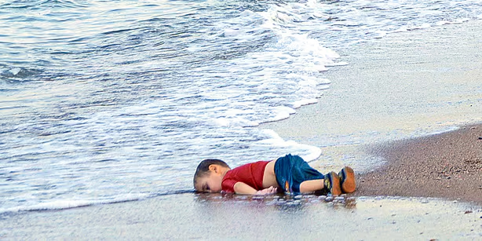
4.2.1 The Death of Alan Kurdi (2015): Visualising Refugee Suffering
The picture of Alan Kurdi is of a three-year old Syrian boy who drowned in Turkey while trying to cross the sea to Europe. The picture was picked up by many news outlets during the European migrant crisis and was used as a symbol of the plight of the refugees. The photograph captures the narrative of personal loss in relation to a broader humanitarian crisis, in a way that is simple, visually engaging and effective, through its composition, camera angle and attention to the child's body.
At the denotative level, in Barthes' terms, the viewer can observe a young little boy in red clothing lying in wet sand close to gentle waves. The beach is empty. No other human body is seen in the frame. The connotative level creates meanings, which are not necessarily literal, from the image. The beach is empty, indicating isolation, and the sea is calm, in contrast to the violence behind the death of the child. The deserted beach gives a feeling of complete isolation. The calm sea in the background is in sharp contrast with the violence of what has happened. Blood, injury, chaos are not depicted. Instead, it is a scene of stillness and simplicity that evokes a sense of sorrow and loss.
The angle of the camera is low, close to ground level. This makes the viewer almost touch the body of the child, as if lying on the same ground. The imagery decision generates a powerful sense of closeness and compels the viewer to be emotionally invested in the scene. The camera is positioned at a lower level and the actions of the child are close to the camera, thus making the observer feel closer to the camera and also to the suffering subject. This is in line with Sontag's claim that pictures of suffering can ‘demand a response from viewers' by establishing an ‘ethical relationship with the distant suffering' (Sontag, 2003, p. 218). The child's simple and colorful clothing allows him to look like any child, and not feel like the distant ‘other’ anymore. Like the traditional iconography of the ‘Pieta' that Sontag discusses, the composition plays off the vulnerability of the child to produce a moral imperative which is even more significant than the immediate geopolitical cause of the conflict (Sontag, 2003, p. 189).
In addition to the visual arrangement of the image, the platforms that transmitted the image of Alan Kurdi also contributed to the meaning of the photograph. The dissemination of the photo via digital news outlets and social media also brought the image wider exposure than that of the news alone. It could reach a wider audience than other media due to the digital platform. Within hours the image grew to become a viral symbol of the refugee crisis. This phenomenon is a case in point of what McLuhan has referred to as a ‘message’ of any medium or technology, “the change of scale or pace or pattern that it introduces into human affairs” (Levine & McLuhan, 1964, p. 646). It is not just the content of the image that in this context “shapes and controls the scale and form of human association and action” (Levine & McLuhan, 1964, p. 646), but the media also does.
Baudrillard's (1995) concept of simulacra helps to explain how Alan Kurdi's photo transcended to represent one death. The image was circulated over and over again, turning into a symbol of the broader refugee crisis. The picture continued to be about the actual event but took on a much wider connotation of being displaced, vulnerable and responsible for humanitarian action. In this way, the image is not only a record, but also a strong symbol in the public discourse on migration.
The overall tone of the photograph is that visual aesthetics can impact the way in which suffering is depicted. The low level of the camera, the emptiness of the background, the simplicity of the composition and the emphasis on the child's body develop a visual language of vulnerability and loss. Meanwhile, the image's dissemination in various media had an impact on the interpretation of the photo by worldwide viewers.
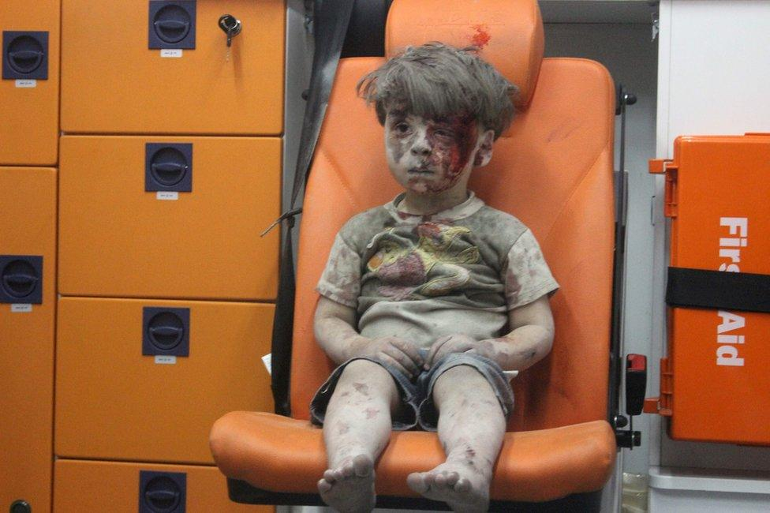
4.2.2 Omran Daqneesh Photograph (2016): Childhood, War, and Visual Silence
The picture of Omran Daqneesh was one of the most iconic images of the Syrian conflict. The photo depicts a young child in a vehicle inside an ambulance, taken from a building that has been damaged due to an airstrike in Aleppo. This image is not like a photograph in which violence is present, but rather it is about the aftermath of war. No one is doing anything – the child is not moving and the expression is silent – which allows a visual representation of the human impact of war.
The composition puts the child in the frame, and his face, which has been cut and marred with dirt, is the primary focus of the image. The colour of the ambulance seat, orange, is offset by the grey dust which covers the body of the child and his pale appearance. This contrast highlights the corporeal impacts of violence, and provides a quiet, controlled mood instead of a visible chaos.
The denotative level of the photograph is a picture of the child alone in an ambulance following a bombing. But this whole situation has a connotative meaning. The child's vulnerability, innocence and gaze of the civilian experience of war are highlighted by the silent expression and direct gaze. The blankness of Omran's face, which is “the ideological baggage that signs carry wherever they go” (Barthes, p. 1) is the strongest element of the image, on the connotative level. A child that had just seen an air strike would normally be crying/screaming. He seems to be in some kind of shock, beyond normal fear. The dust on his face and body tell of what has just transpired. The dried blood indicates some sort of injury, but not emergency, which gives the feeling of a different sort of sadness to the viewer than if it had been fresh blood. It's a really simple expression of war's silence. The stillness of the image conveys a message of not only fear, but of life in war.
The image is a reflection of Meis's (2016) idea of the aesthetics of conflict, as he has not directly shown a scene of destruction but presented violence through its absence. The background is plain, and the composition is simple, with Omran in the centre of the frame, minimizing distractions. This framing draws viewers' attention to his face, clothing and physical condition, making the effects of conflict the central theme in the image. The impact of the image is not in what is depicted, it is a still image that is filled with trauma and emotion. Images of conflict can produce meaning by means of visual decisions that will influence viewers' perception of conflict, as Meis (2016) suggests. The lack of physical violence gives the viewer the opportunity to visualize what went on outside of the frame, as O'Loughlin puts it, “the affective power of mediated absence” (Meis, 2016). Thus, the image of the photo is not as graphic as it is a portrait-like composition that implies a human effect of war.
The image also captures the theme of images of suffering as put forth by Sontag (2003). The image does not depict the actual act of violence, but instead the results of violence -- the child's expression and its injured body. This is a form of witnessing that is not done in pictures but rather in silence and emotional restraint and in suffering. Whereas the photo of Alan Kurdi is a kind of suffering by not being there and by being still, Omran Daqneesh's photo is a suffering by being there and by living on. In both images, the subjects are suffering from the consequences of war and displacement, with the image of Alan Kurdi being about death and displacement, and the image of Omran being about the physical and emotional toll of war. The circulation of the photograph in the global news and digital media also influenced the meaning. The image circulated through various media and Omran became the symbol of civilians suffering in the Syrian war. That is a good illustration of the effect of the circulation medium on the understanding of crisis images outside of their original context. The photo shows how an aesthetic choice is employed to depict suffering. The composition is central, the colours are muted, the framing is close and the content is focused on the child's expression, thus forming a visual language of vulnerability. Meanwhile, the picture poses moral issues concerning the representation of an individual's suffering as a political issue.

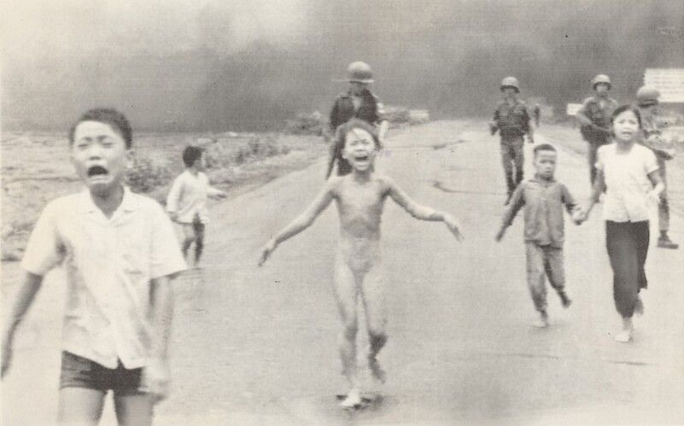
4.2.3 The Napalm Girl (1972): Visualising Civilian Suffering in War
The Napalm Girl photograph has been chosen as a crisis image because of its portrayal of the suffering of civilians during armed conflict, and its visual power of revealing the human side of war. The photograph shows a scene from the Vietnam War, featuring a group of children running away from a group of men who are holding them in a circle, one of whom appears to be carrying an object. In the center is a young girl named Phan Thi Kim Phuc whose burnt clothes have been ripped off. She can be seen to have burnt skin. As a denotative level the shot highlights the burnt skin of the main character. A girl in the middle of the frame and a few children running along the road. The depth of field has brought out her clearly, but the blurry background, at the same time, has created a heavy backdrop. The overall setting with the soldiers in the background makes the scene a series of time snapshots. Connotatively, the image evokes pure terror, pain and the inability of adults to protect children. The image shows the direct physical effects of war and the child's body as the focal point of the image.
The depth of field of this photo is important. The central figure is in sharp focus, while the surrounding details, such as the soldiers and smoke, are somewhat blurred. This visual decision leads to a shift of focus in the viewer's perception, to the child's body and his/her face before the military context in the background. The series of looks are tightly planned. The first thing the viewer sees is the suffering child, and then the reason for the suffering. This is an example of the use of focus to direct the image of suffering that's built into the image. The photograph is not only documenting a historical event, it is also establishing a hierarchy of the image; the child's suffering is the crux of the crisis. This method emphasizes the suffering of humankind, and not the broader military conflict. Thus, its image builds the crisis mainly off the visible effects of violence on the civilian body.
To analyse this photograph, one can draw on Sontag's (2003) talk about the ethics of representation of suffering. The photograph is about the effects of war, but it also poses issues regarding the representation of the body of an injured child. The photograph is thus rife with tension, both in its depiction of the horrors of violence and the prospect of transforming suffering into an aesthetic object. But it does pose ethical issues of taking a child's naked and injured body picture. The ethical dilemmas that arise when photographing documentary subjects are particularly intrusive in the case of this girl, who later said that she struggled to be known solely by this image of her suffering (Guerin, 2017, p. 65).
In Said's Orientalism (1978) it is significant to note that this image depicts an Asian child as a victim of a military operation by the West. It was created and circulated for a predominantly Western audience and played out in what Said labels as a theatrical framework, "the Orient is the stage on which the whole East is confined" and "on this stage will appear figures whose role it is to represent the larger whole from which they emanate" (Orientalism, 1978, p. 15). The picture depicts an Asian civilian who was a victim of the war and was widely published to international audiences. This doesn't take away from the significance of the photograph, but it does remind people that these images of humanitarianism are created and comprehended in political and cultural contexts. The above examples of news media demonstrate variations in visually building suffering. The Napalm Girl offers direct sight of physical injury, without the suffering having been shown; Omran Daqneesh is a picture of the aftermath of violence; Alan Kurdi is a picture of stillness and absence. In the next section, the war photographs are replaced with images of poverty and famine, to look at the representation of suffering in humanitarian photojournalism.

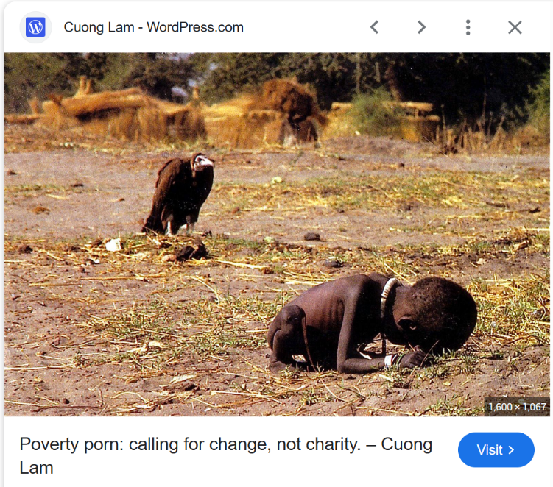
4.2.4 The Vulture and the Little Girl (1993): Ethics and the Aesthetics of Suffering
The picture is used as a crisis picture because it shows the impact of a famine and of being extremely vulnerable. This image is not a war photo that depicts acts of violence but rather the suffering is created by the interplay between the human body, the environment and the symbolic elements within the frame. In this photo by photojournalist Kevin Carter, a small and very thin child sits on the ground, during the Sudanese famine. There is a vulture standing near her in the background. At the level of denotation, there's a small, very thin child sitting on dry, cracked ground. A big vulture is standing nearby, positioned near the child. The earth seems desolate and dry; the child seems weak and lonely. That's what the image shows on the surface just a child and a bird in a barren landscape.
However, it is where the connotation comes in that things get more complicated. Barthes (1964, p. 6) suggested that, making the apparently "simple scene" more powerful and more disturbing. Because of the vultures' significance in our culture, the bond between the child and the vulture is disturbing. These birds wait for the dead, they feed on the dead. Thus, from the child's perspective, when a vulture is seen standing near a child, the proximity between the child and the vulture makes an association with danger, death and extreme vulnerability.
This time, the most difficult question in the world of photojournalism is whether or not taking a picture becomes part of the problem, or part of the answer. Susan Sontag explored this exact dilemma in her writings about images of suffering, She pointed out that "the rest of us are voyeurs, whether or not we mean to be" when we look at images of extreme suffering (Sontag, 2003, p. 34). It's a decision made by the photographer, in this case Kevin Carter, that many people could not forgive. The picture sparked moral questions of how to create a strong image and what the ethical obligations of photographers are in showing human suffering. This is where the fundamental moral debate lies. The job of the photographer is to produce a compelling image, and make people sit up and take notice of humanitarian crises. As a person, however, there's a responsibility to help when someone's in danger right in front of you. Carter was awarded a Pulitzer Prize for this photograph, but was heavily criticized by the public (Fehrenbach & Rodogno, 2015).
This photograph is not only an issue of ethics, but also an example of the problem of humanitarian photography in general, that is, the use of vulnerable subjects to deliver the message of crisis. Fehrenbach and Rodogno show that 'the image of the dead or suffering child has long been a focal point of humanitarian campaigns, for more than a century now' (Fehrenbach & Rodogno, 2015, p. 1121). Images can attract attention to a crisis, and go viral and iconic, like Carter's photograph or the recent one of the dead child Alan Kurdi who washed up on a beach in Syria. But the distribution of such pictures engenders a tension between greater awareness of suffering and the respect for the dignity of the people involved. As organisations, it is important to balance the representation of real in relation to suffering with respect for the dignity of the individual represented. So, the next question is does it help this child and children like her by drawing attention to her pain, or does it use her pain as a prop to something that may have no bearing on her? (Chouliaraki & Stupart, 2025, p. 7)
One of the main tensions in this photograph is the connection between aesthetics and ethics of representation. The dry landscape, the location of the child and the vulture provide a good visual structure that helps to compose the emotional sense of the image. At the same time, the same aesthetic characteristics lead to doubts about the power of the image of suffering and the loss of dignity of the subject. The Vulture and the Little Girl highlights issues of ethical representation of extreme vulnerability, but the following examples by James Nachtwey and Lynsey Addario offer alternate ways of capturing suffering, in which composition and dignity are issues.
4.2.5 James Nachtwey and Lynsey Addario: Aesthetic Approaches to Representing Suffering
Another way to depict suffering is what is done by James Nachtwey and Lynsey Addario, who use visual detail, environment and the focus on the individual to show suffering in human rights and humanitarian efforts. Their photos are not as shocking as some of them, as they may include aspects of dignity and presence of humanity in the midst of hardship. This section focuses on the representation of suffering in their work, by analysing the contribution of composition, lighting, colour and framing. The frames are often very cluttered with hands, objects, dust and/or the remains of structures. The subject is typically situated in a central position, with elements providing context to their situation. This is a compositional method, which situates individual suffering in a broader context of suffering. It lets the photo convey their own story and the broader context of the crisis. According to Meis (2016, p. 73) this approach aims to evoke a profound emotional response from viewers by creating a sense of immediate and raw, and depict suffering without being sensationalist.
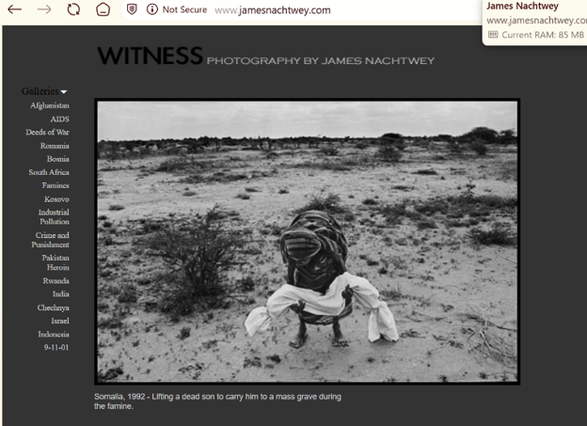
Image 1: James Nachtwey
The photo is a black and white image of a woman with a small bundle wrapped in white cloth, standing in a dry landscape. The surrounding area features a field with no vegetation, some trees, and a clear sky. The lack of color contributes to the seriousness of the image and to its restraint, drawing the viewer's attention to the human figure and the environment. The Connotation of the photograph is- the "white cloth" has a strong connotation as a burial shroud conveying the idea of death and ritual purity. When lifted by the child, it is a burden, but the connotations are the "weight of grief" and the "weariness of loss" in the Somali famine. The black and white photography is used to “de-spectacularize” the color of suffering, while highlighting the “texture and weight of real physical spaces”, the visual style creates a connection between individual suffering and the wider social conditions surrounding famine.
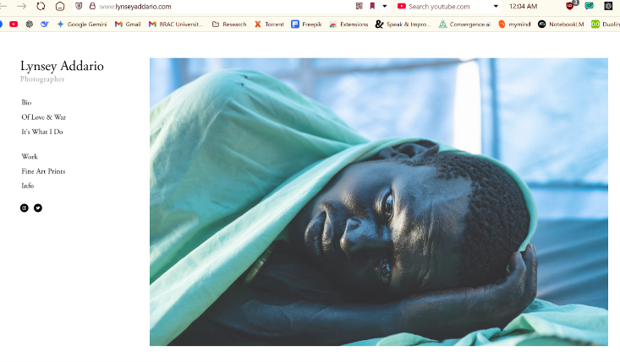
Image 2: Lynsey Addario
Addario's photo is different with its colour and close framing and direct eye contact makes it a different portrayal of suffering. A person lying on the ground, wearing a light green cloth, and facing the camera. The soft lighting accentuates the face and the fabric's texture. The teal cloth may suggest a connection with medical care, recovery or vulnerability, describing a space of "waiting" or "recovery" (Bellander, 2021). The subject's direct look provides a "subjective" link that changes the connotation from "spectacle of suffering" to the unique story of resilience and dignity. But the visual beauty of the composition, the vivid colour and the careful framing, makes for what Sontag termed a "complicated ethical situation" as the beauty of the image might become more important than the tragedy of what the subject is showing (Sontag, 2003).
Sontag's understanding and analysis of the aesthetics of suffering comes in handy when considering the tension between the documentary value and the visual beauty. She addresses the "dual powers of photography" to act as document and artwork in her seminal work Regarding the Pain of Others (2003, p. 60). Images of suffering can serve as documentaries of events and as well-composed photographs. Sontag says the aestheticization of suffering, the making of photographs "beautiful," raises a moral dilemma; photographs may hold the attention of the viewer aesthetically without encouraging the viewer to do something. In particular, Nachtwey's photographs are famous for their visual beauty, which has raised questions from critics on whether the beauty of the pictures is what makes them compelling to audiences, and not the poverty and hardship that they portray, as has been a central ethical issue in humanitarian photography (Sontag, 2003).
It is this "ethical tension" that is reflected in Nachtwey and Addario's work. Nachtwey frequently refers to "established visual narratives of affliction" like the iconographic lines of the Pietà or Descent from the Cross in order to give his subjects a tragic "aura" which can end up favouring admiration over action (Sontag, 2003). Sontag also speaks to the "diminishing effect" of image "hyper-saturation" that results from seeing too many atrocities, "shriveling sympathy" and cultivating callousness. However, she highlights how such pictures continue to be important for "shaping what catastrophes and crises we pay attention to" as evident in the 'CNN effect' which made the siege of Sarajevo known to the world (Sontag, 2003, p. 81). In the end, both photographers strive at a balance between the "stark realities" of the image and the danger of fashioning a "spectacle" that would make the image more beautiful than morally pressing (Sontag 2003, p. 186). This careful balance between truth and possible aestheticization emphasizes the continuing ethical concerns related to the depiction of human suffering in the photographic medium.
As the examples of photojournalism illustrate, suffering can be depicted in a variety of aesthetic ways. Some of the images highlight vulnerability and crisis, others try to convey dignity and presence. The next section will look at images used in NGO campaigns, which have a different institutional function, such as advocacy and fundraising.
4.3 NGO Campaign Images: Humanitarian Appeal and Visual Representation
NGO campaign images are in a different institutional context to news photographs. Such images typically are generated or disseminated by the Web sites, campaigns and social media of humanitarian organisations, as visual communication relates to advocacy, public awareness and fund-raising. Hence, the following is a look at composition, colour, typography, symbolism and platform design and how they play their part in representing suffering and humanitarian action. This includes examples from UNICEF's emergency response for the Republic of Sudan, fundraising webpage images, IHR's ‘200 Shelters' campaign, Minbar Al-Aqsa’s ‘1,000,000 Hot Meals' project, ‘We Fast but Have No Food' social media post and UNHCR visual storytelling materials.
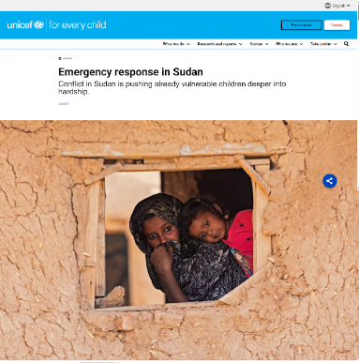

4.3.1 UNICEF Emergency Response Campaign (Sudan): Constructing Humanitarian Urgency Through Visual Framing
UNICEF's campaign page for the Sudan emergency includes a picture of a woman and a child set against a cracked and damaged window in a mud wall. Below the picture, there is an explanatory text saying, “Emergency response in Sudan.” Striking, human-centered imagery, simple colors and layout use a visual approach to highlight the children's suffering and prime viewers to act, and in the process show how humanitarian media can be calm and emotional, but still promote humanity and support for children in crisis. The image is thus not only read as an image of crisis, it is also read as an element of a communication environment of the NGO, which is composed of image, text and webpage design.
Connotationally, the broken window is a potent emblem of destruction, loss and division between safety and danger. The woman and child are placed in the frame of the window as if they were looking out into the viewer's world from a broken world. This visual structure forms a moral bond between the spectator and the portrayed person. The viewer is outside, safe, and the subjects are inside of the broken reality. This positioning establishes a relationship of the person depicted to the person looking at the campaign. The image uses vulnerability and need as a lens through which to consider a humanitarian context linked to a potential for support. Scholars have written about how women and children are used as the protagonists of humanitarian campaigns, as a representation of the “ideal victims,” with vulnerability as one of the most significant elements used in humanitarian communication (Ongenaert & Soler, 2024). Deliberate focus on vulnerable topics, with the presumption that vulnerable people will be more innocent to evoke the emotional response and greater effectiveness of the fundraising campaign, even if there are ethical concerns about reinforcing the idea of victimhood.
McLuhan's notion 'the medium is the message' is helpful here as the image is displayed in a web space with text, buttons and interactive features. This campaign has a website as a medium so there are many texts, buttons, and interactive elements surrounding the image. The viewer is not only viewing an image, he or she is being directed by the design to a particular action, that of giving. Here typography is very much part of the equation. The 'DONATE NOW' button is prominently sized, eye-catching and is positioned very near the image. This visual proximity puts an emotional and practical relationship between feeling and doing. Typography not only conveys information, but also plays a role in the organisation of the presentation of the campaign message.
It is an illustration of what Chouliaraki (2025) has termed the ‘positive style’ of humanitarian communication in which images are meant to evoke the viewer's empathy and sense of potential action. There is no extreme suffering or graphic violence in the image. Rather, it demonstrates a quiet, but obviously challenging situation. It's a matter of aesthetics, and perhaps a calculated aesthetic choice. The UNICEF example has been mentioned as a good example of how images of an NGO can be used in a campaign design and give it a visual element. The following examples illustrate the use of individual faces, text and symbols to link suffering with forms of assistance by humanitarian organisations.

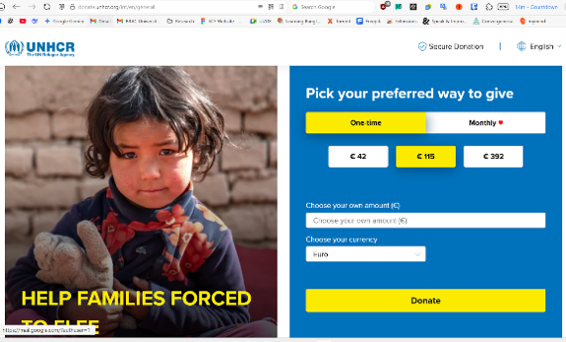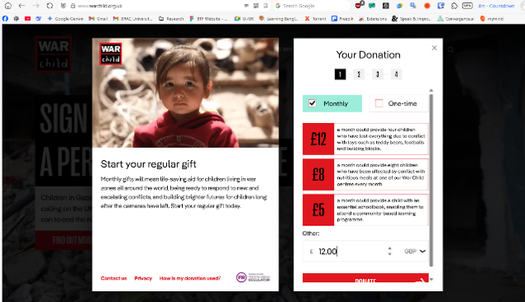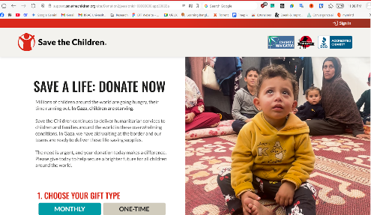

4.3.2 Fundraising Webpages Using Emotional Photos
Images of children are a major visual feature of the selected fundraising webpages. These typically include close-ups of people's faces, brief text and donation-related design elements. The campaigns build meanings of vulnerability, urgency and humanitarian responsibility through these visual elements. Denotatively, the fundraising images depict children in the middle of the picture, with soft focus background shot and easily readable, colorful text, for example- ‘SAVE A LIFE’ near them, connected with a call for humanitarian support. The connotative level of these visual choices relate to the innocence and vulnerability of the child. The image along with the text frames the crisis as an issue that needs humanitarian attention. The buttons and accompanying text connect the emotional message of the image with the practical process of donation. Phrases such as “SAVE A LIFE” and “HELP FAMILIES” are short, simple and located next to the pictures to turn emotion into action by donating.
One of the most common visual strategies in humanitarian communication is to zoom in on the eyes and face of a child, thus producing a personalised image of crisis. This frequently results in the "sacralization of children" in media; the child image is employed as a symbol of suffering, thus compelling the spectator to take action (Åhs et al., 2023).
According to Joel R. Pruce (2017), the "desperation motif" is a reoccurring visual pattern in humanitarian communication that portrays vulnerable subjects as the means to communicate crisis.This is based on "blank, staring eyes" and the "innocence of childhood" to individualize the suffering at a distance, to frame the situation as requiring humanitarian attention. To transform the image's imagined proximity into a humanitarian practice. But these photographs also pose questions of the power dynamic between the viewer and the victim. However these photographs also raise questions of power relations between the viewer and victim. Susan Sontag (2003) discusses the ways in which our responses to images of suffering and war can be complex in relation to witnessing suffering and comprehending the larger causes. it.
The incorporation of specific tiers of giving (as illustrated in War Child and UNHCR screenshots) is indicative of the "post-humanitarianism" of solidarity, in which solidarity is increasingly brokered through the market (Chouliaraki & Stupart, 2025). Instead of depicting a "passive patient," the visuals are now "transactional," with a certain number of dollars linked to a certain amount of aid, such as "a schoolbook" or "nutritious meals. Chouliaraki's work on the market economy of humanitarian imagery shows that the visuals can not only be linked to a certain amount of money, but also to an amount of aid: "a schoolbook" or "nutritious meals. (Chouliaraki & Stupart, 2025, p. 6). This strategy makes it easier to undertake humanitarian action because it tangibly links a particular amount of action with a particular result, and larger, more systemic issues that can trigger crises may be ignored. These images illustrate how the humanitarian campaigns are assembled through the use of child images, clear typography and textual messages to create specific images of suffering and potential aid.
Fundraising web pages often feature personality pictures and messages, but other NGO campaigns feature personality pictures and specific numbers, projects and forms of assistance. This example illustrates the use of text and visual symbols for the representation of humanitarian solutions.
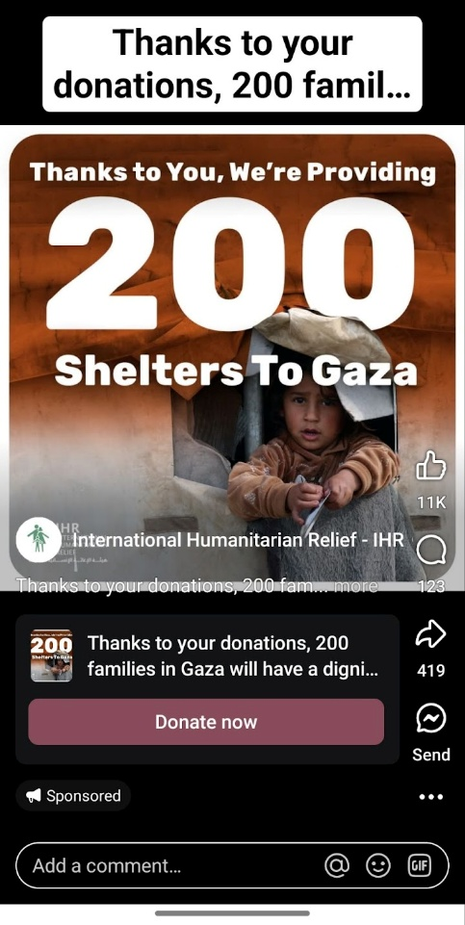
4.3.3 IHR “200 Shelters” Campaign: Linking Individual Suffering with Humanitarian Solutions
International Humanitarian Relief (IHR) has released this fundraising image, a close-up photograph of a young child in a destroyed setting. The picture is accompanied by bold text stating that 200 shelters will be donated for families in Gaza. This blend of image and written information is significant in the sense that, the campaign is not merely about suffering but also about associating the suffering image with some particular humanitarian assistance. Denotationally, it's a kid's face, and some text about shelters. On the level of connotation, meanings of vulnerability and humanitarian need are constructed by the child's expression in a context of destruction.
The face of a child together with the number, 200 shelters, is a particular visual technique There is literature on humanitarian communication that has been considering the idea of individual faces used for broader issues in the humanitarian field. In this campaign, the kid's face is juxtaposed with the figure "200 shelters" to link an individual with a humanitarian project. This tactic may be based on the “identifiable victim effect” in which explains how identifiable individuals can become a focus of humanitarian representation compared with anonymous statistics (Bayram & Holmes, 2021, p. 3). This approach is based on the psychological identifiable victim effect, in which “it is easier to feel psychological proximity to identifiable victims than anonymous victims” (Bayram & Holmes, 2021, p. 3), and the bold typography of 200 shelters, which, as in visual semiotics, makes "meaning making choices by means of proximity" (Bellander, 2021, p. 313) that anchors the image to a specific, solvable crisis. The campaign attempts to help the big number have an emotional impact by linking it to the face of one child, identified by the number '200'.
Barthes' semiotics can be used to understand the text - image relationship in this campaign. In Barthes' system, text may serve as an ‘anchor' that determines an image's meaning (Kohrs, 2020, p. 266). The text can serve "direct the reader through the signifieds of the image, causing him to avoid some and receive others" (Kohrs, 2020, p. 266) as Barthes says. An anchor here is the text 200 shelters. The image by itself depicts a sense of vulnerability, and the text provides a humanitarian context for the image. The text is linked to a particular and remedy-based suffering (shelter). It links the visual representation of suffering to a particular humanitarian response through the use of image and anchoring text.
The IHR campaign is an example of successful use of NGO images to complement written information and to develop a clear humanitarian message for the public. In the following example, the emphasis is not on the actual suffering, but on how suffering is represented and the responsibility of providing aid and food.
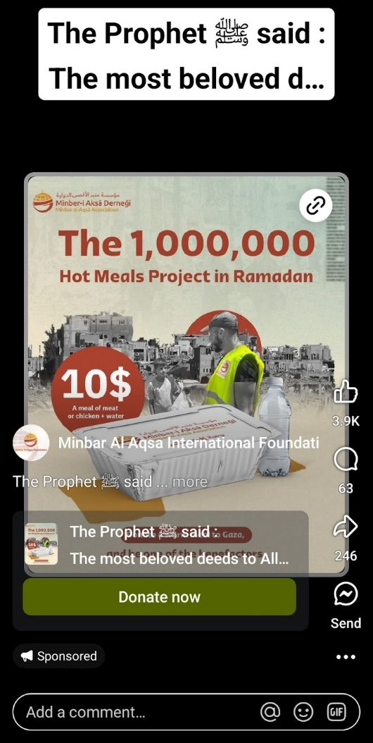
4.3.4 Minbar Al-Aqsa’s “1,000,000 Hot Meals” Project: Food, Religion and Humanitarian Representation
The campaign visuals frequently exhibit neat box of food on simple surfaces, with hands reaching in from the edges. It features a project that is delivering hot food during the month of Ramadan. There is a photo of a volunteer feeding a large number of people and the number “1,000,000” communicates the scale of the humanitarian project and gives the campaign a clear numerical focus.
In the background, there are also some ruins of buildings, indicating the context of the site. This unique fusion of food, destruction and numerical information establishes a visual link between crisis and humanitarian response. This contextualisation focuses on the connection between the challenging situation depicted in the picture and the humanitarian response shown in the campaign. The visual approach is in keeping with scientific studies showing that a representation of the concrete consequences of the aid in a destroyed environment may additionally improve the donors' motivation because the direct alleviation of suffering is clearly illustrated (Meis, 2016, p. 80). The use of the viewer's knowledge of shared religious rituals during Ramadan also creates a feeling of common humanity and shared responsibility to those in need. The image is a poignant portrayal of the suffering and the need for help, while also emphasizing the importance of community responsibility. It also demonstrates how an effective visual approach to humanitarian media can have a very powerful impact on the emotional response of people.
This campaign shows a different face of the images of humanitarian issues, which primarily depict suffering that is visible. Rather than focusing on the image of a suffering body, it focuses on the distribution of food, as a symbol of humanitarian support. Traditional fundraising approaches typically do so by creating a “landscape of suffering” that generates a response for help, but the aesthetic approach of this campaign is different (Pruce, 2017, p. 2). The food boxes are clean and well organized. The campaign doesn't demonstrate the suffering that generates the need, it demonstrates the solution: food. It illustrates the need through the use of the large number. This visual is barely alarming, it is rather motivated to the viewer, which fits into theories that Meis (2016, p. 73) described as 'how reality and “solutions” are perceived' by the viewer media aesthetics. The visual style has less of a shock effect and more of an effect of providing assistance and potential solutions.

The timing of this campaign, for example, in the context of the Ramadan, is also important is equally significant as it imparts a particular religious and cultural context to the image. For those who know the context of fasting and food assistance, these references can be interpreted as having meanings associated with charity, shared responsibility and religious practice. The images have religious and cultural meaning that is unique to the audience, which is termed as a "sympathetic da'wah strategy" that seeks to convey religious messages to audiences based on their current situation to achieve specific social implications (Halid & Fajrin, 2023, p. 2). This is an example of the humanitarian visual communication that is culturally specific. These symbols, however, have different meaning depending on cultural background and social context and cannot be understood in the same manner by every audience.
The spread of this campaign on social media is also significant due to the graphic of the campaign and the limited wording that is used, making it easy to share. The food images are simple, clean, and have a simple visual style that is appropriate for these platforms where food images must be able to grab people's attention and be easy to read within a short period (Halid & Fajrin, 2023, p. 2). The big figure of "1,000,000" is easily understandable and gives a sense of scale even to a fleeting glance of the image. According to McLuhan, as quoted in Levine & McLuhan (1964, p. 646) "The medium is the message because it is the medium that shapes and controls the scale and form of human association and action. This campaign's “message” is not just the food itself, it's the “change of scale or pace” that the digital medium offers to the humanitarian endeavor. The Minbar Al-Aqsa campaign shows that images of humanitarian nature are not just for the purpose of showing suffering. The next social media example again connects to that of an individual child, as personal expression and text/digital circulation drive another type of humanitarian representation.
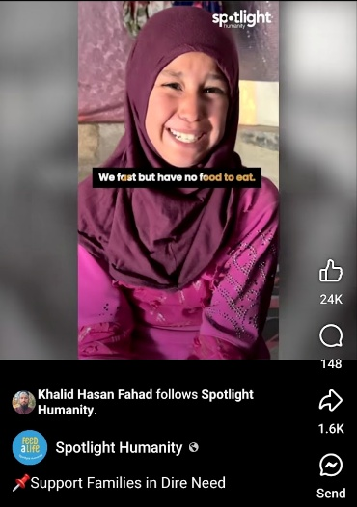

4.3.5 “We Fast but Have No Food” Social Media Post
The image shows a young girl with tears in her eyes and a smile on her face, wearing a purple scarf. Denotatively, the image depicts a child's face and the text “fasting.” Connotatively, the faces, the clothes and the text, all add up to some idea of hardship, dignity and resilience. This is a departure from the conventional "shock effect" in humanitarian visual communication that typically depicts a passive, helpless victim to a "positive style" or "deliberate positivity" that presents the subject with a stronger sense of dignity (Bellander, 2021, p. 314; Ongenaert & Soler, 2024, p. 289). The campaign portrays the child, not just in suffering, but also in the expression of his or her own presence, his or her own dignity.
The lighting is gentle and warm, drawing attention to the girl's face and expression, while the background is blurred, minimizing distractions from the main focus of the image. The portrait is composed in a close-up shot, which is a common approach in humanitarian photography to draw more attention to the subject. Further, the first-person perspective of the sentence “We fast but have no food” establishes a direct connection between the experience depicted and the message of the human situation. It can also be understood from the concept of a “sympathetic da'wah strategy” which is the ability to link religious meanings with humanitarian communication (Halid & Fajrin, 2023).
For the case of this image in circulation through social media, McLuhan's (1964) idea of “the medium is the message” can be utilized. Finally, the message of this campaign is not only the image itself, but the scale and form of human association and charitable action engendered by the digital medium. The informal image of mobile phone photography can produce a different style of visual image as opposed to professional humanitarian photography. The not as high quality image and personal style might add to a sense of immediacy in digital circulation. This fundraising campaign example on social media demonstrates the use of suffering in communication, which may include personal expression, religious language and digital visual style. UNHCR's storytelling via its website is explored in the next section, under a more institutionalized umbrella.
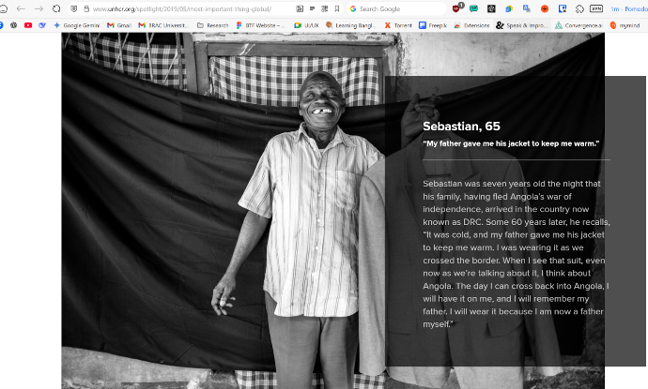
4.3.6 UNHCR and NGO Website Visual Storytelling
Many NGO websites, including UNHCR, feature images on them that are portraits of people as well as pictures of their surroundings. Refugees are often shown in close up and medium shots, thus giving them a sense of personal displacement. The subjects are depicted in their tents and/or in makeshift shelters with the surrounding landscape. Shots are calm and centered with framing that is intimate, close, and real to create empathy with viewers.
This is a visual approach that mirrors what Bellander (2021, p. 328) have identified as a “dignified” shift in humanitarian photography from passive victims to the humanity and strength of people in difficult situations. Organizations try to avoid the use of traditional humanitarian imagery which historically has portrayed people in crisis predominantly in a vulnerable manner, the "shock effect". The composition is centered, and the overall scene is serene, indicating respect for the subject. The environmental detail, which illustrates the situation of displacement, gives context without exaggerating the suffering.
Said's concept of ‘Orientalism’ is a useful way of thinking about how images of non-Western subjects can be related to the broader structures of power. In terms of humanitarian photography, this creates a number of issues regarding the framing of refugees and displaced persons and the way in which their identities are portrayed to the outside world. Said captures this power dynamic, when he says:
"It is Europe that articulates the Orient; this articulation is the prerogative not so much of a puppet-master as of a genuine creator, whose life-giving power represents, animates, constitutes the otherwise silent and dangerous space beyond familiar boundaries" (Said, 1977, p.10).
This criticism has been met to some extent by the adoption of more dignified methods of photography. However, some researchers like Ongenaert & Soler (2024, p. 294) argue that even in ‘dignifying' images there are some researchers that argue that there is still a power imbalance between the viewer and the subject in that the image evokes emotions of pity and guilt mainly targeting women and children, thus creating what is known as “ideal victims”. Even more respectful representations can raise questions of power, authorship, and who controls humanitarian narratives, as this critique demonstrates.
The NGO examples show that images of humanitarian issues are not only affected by what is being depicted, but also by the institutional function and the communication context. Next, social media images are explored, as the conditions of circulation and sharing processes as well as the platforms themselves offer distinct ways of understanding representations of crises.

4.4 Social Media Images: Digital Circulation and Changing Meanings
Images of the Gaza conflict in social media are another type of crisis photography since they are manufactured and disseminated in a digital space that allows for quick dissemination of visual products by users, journalists and organisations alike. These images were spread in mainstream, social and independent digital media. The chosen examples are an image of a child among ruins, a widely circulated image of bodies in the air and a political cartoon that relates to military violence. These examples are analysed and explored for how digital circulation, captions, symbolism and visual framing help create meanings of crisis.
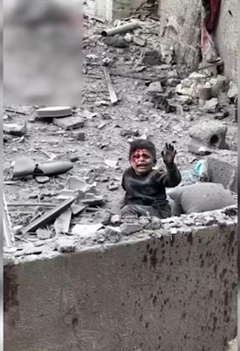
4.4.1 Gaza's Children: Representing Vulnerability Through the Ruined Landscape
The photo depicts a single child standing or seated in the midst of what appears to be a collapsed concrete structure. The image is captured from a broad angle, encompassing numerous visual elements such as damaged walls, dust, damaged buildings and irregularly shaped forms. The child's body is small, in comparison to the rest of the ruins. The overall wide shot sets the child in a fairly expansive area of destruction, thus establishing a visual connection between the figure and the landscape. Close up portraits are a feature of many humanitarian images to establish a personal connection. That's where the frame comes in a different way. It depicts the child as small and alone in a big field of devastation. This composition is more about the magnitude of destruction as opposed to just a portrait of one. Violence is thus brought into the world of the child, who serves as a symbol of innocence.
The child in this image is a powerful connotating sign as seen through Barthes's (1964) ‘semiotics’. In many cultures, a child is a symbol of innocence, the future and vulnerability. When a child is placed in a destroyed world, symbolic meanings that are related to vulnerability and insecurity and the human consequences of conflict are created. The child's surroundings that devastated landscape gives added significance: collapse, loss, certainty of destruction.
Meis's framework can be used to comprehend how this image's visual ‘look’ helps to create the crisis. The focus on the 'aesthetics of crisis' is seen in the way the ruined urban landscape and the child's vulnerability is framed, which evokes much more than a denotative narrative, signifying a sense of loss and of systemic failure (Meis, 2016, p. 71). The visual representation of this scene, with a focus on the physical destruction and the lonely child, creates an explanatory structure that is constructed through the demonstration of similar scenes and thereby give the viewers some means of validation of the suffering that is portrayed (Meis, 2016, p. 78). The dust in the air gives a soft and hazy look. Walls that are fractured to form an irregular texture. These factors contribute to a feeling of realism and freedom in the image, contributing to the documentary appearance of the image. This is the aesthetic quality of the image unfiltered and raw, that is also a strategy for making the image have greater emotional and ethical power. The image is symbolizing the suffering, through the bond of a vulnerable person and a wounded environment. The following example explores another type of digital crisis imagery, one in which distance, captioning and the dissemination of an ambiguous visual form affect the production of meaning.
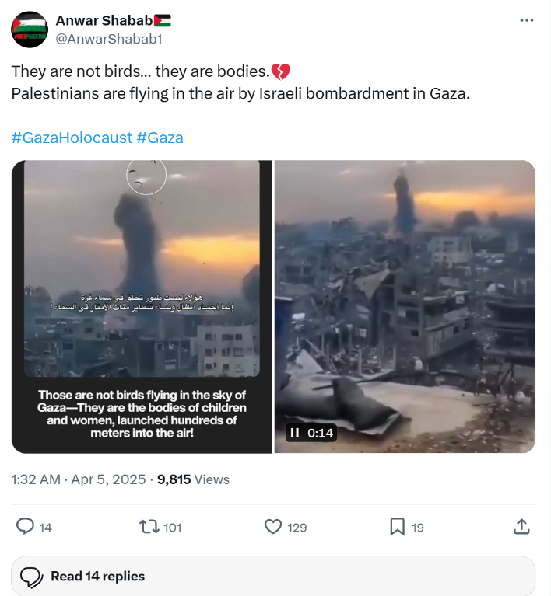

4.4.2 They Are Not Birds… they are Bodies in the Air
This picture is dark and has indistinct forms, and was shared on social media. “They Are Not Birds... They Are Bodies,” the caption, is significant as it offers a certain interpretation of what is not clearly visible in the image. The image is a photograph taken with a mobile phone, showing a night scene with dark, indistinct forms against a backdrop of a sunset-like sky, likely during an Israeli bombardment in Gaza. On the level of denotation, using the approach of Roland Barthes in Semiotics, the viewer sees small dark dots in a large background of atmosphere. But the linguistic anchor, "They are not birds... they are bodies" activates a violent connotation, changing the viewer's perception from the abstract shapes towards what Bratchford calls the "visceral reality" of human remains (Bratchford, 2014, p. 156). The image may be explored in terms of the “aerial gaze” that distance and vantage points create in the image of contemporary warfare (Tidy, 2016, p. 103).
To quote Susan Sontag from Regarding the Pain of Others:
"Sight is effortless; sight requires spatial distance... there is something morally wrong with the abstract of reality offered by photography; that one has no right to experience the suffering of others at a distance, denuded of its raw power" (Sontag, 2003, p. 118).
The image establishes a physical separation, which is a distance between the forms and individuality. The subjects are hard to identify, raising questions about “decontextualized entertainment” or “war porn”, as Joanna Tidy (2016, p. 103) dubs it in some online circles, relating to concerns about looking at images of violence in a location that is far from home without enough context.
Baudrillard's notion of simulacra can be used to account for the fact that an image can become a symbol beyond its moment of creation, through digital circulation. Here, the caption, which is a quotation from a poem, conveys a meaning that goes beyond the image and the visual form of the photograph is ambiguous. And this is why it may create a real connection towards the people. As this example illustrates, the images on social media frequently rely on the interplay of the visual and written language. The second example explored in the following section, political cartoon, utilizes symbolism instead of photographic realism as the principle means of conveying crisis.
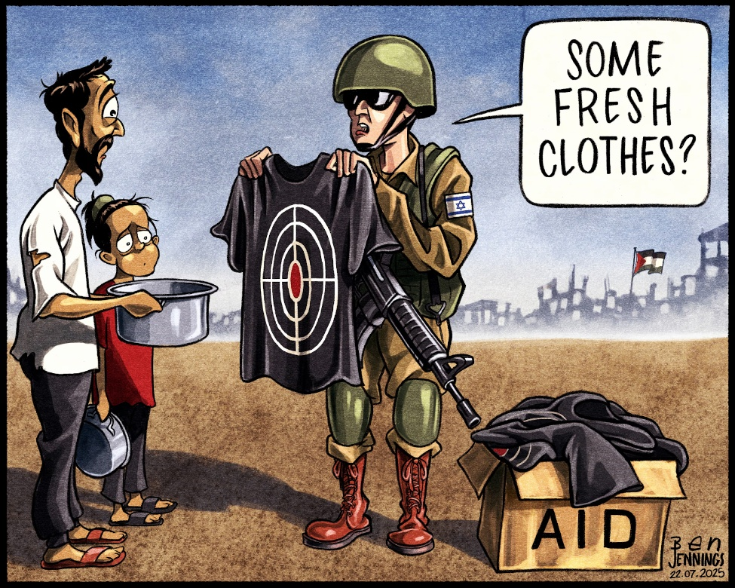

4.4.3 The Cartoon on Israeli Army Strikes
This image is a political cartoon, not a documentary photograph, unlike the previous examples. It is included because crisis images can take symbolic and illustrated representations as well. The analysis thus does not concentrate on the photographic realism, but rather on the meanings generated by the use of visual symbols, composition and text in the context of the suffering and conflict of human beings.
This political cartoon depicts two characters standing on opposite sides of the illustration. The man on the left seems to be holding a small child, with a tired expression. On the opposite side, there is another soldier in military attire carrying a weapon with a target symbol on the uniform. The composition is simple and straightforward. Contrast and symbol are used to create meaning, but not photographic realism. Thus, this image's visual approach is different from documentary photography that elicits meaning through the capacity to appear to record an event.It's a great message about wars and mankind in the cartoon.
In examining this political cartoon, the semiotic analysis of Roland Barthes (1964) can be applied primarily to the connotational meanings since the symbols are created rather than taken from a reality. Literally, it represents a simple combination of two characters on opposite sides of the frame a tired father holding a baby and a soldier in a military uniform with a target on it. Each element, however, is connotatively a mythical sign, the father's tired face as desperation and paternal helplessness, the child's small size as unprotected innocence, the soldier's weapon and uniform can be interpreted as symbols of military power, while the target icon suggests ideas of threat and vulnerability. All these signs contribute together to make a visual argument on violence, vulnerability and the unequal relation civilians/military power. Through this process, the image illustrates the tools available to visual creators and their decisions regarding symbols, characters and composition to create a visual narrative. Such options shape the meanings that the image conveys regarding crisis and suffering (Bellander, 2021, p. 313).
While the handmade image, such as a drawing, is free to make an argument about events, as Sontag (2003, p. 38) notes, “A photograph is supposed not to evoke but to show.” Perhaps the purest form of this is the political cartoon. Unlike a photograph, a political cartoon does not purport to be a simple record of an event. Rather, it illustrates, symbolizes and exaggerates to convey a specific interpretation. This sense of openness about the argument is unique to the image, as opposed to that of the humanitarian image in photography, which is somewhat veiled (Sontag, 2003). The cartoon is simple and concise image communication, and as such a limitation as a representation of reality. To illustrate the use of symbolic visual language in crisis representation, as opposed to photographic documentation, the cartoon was used. It is the relationship between characters, symbols and composition that create its meaning.
The social media examples show that there is not a singular visual form to the images of crisis. Means are constructed through different aesthetic strategies and media contexts, such as photographs, captions and illustrated images. The patterns found across news media, NGO campaigns and social media are compared here.

4.5 Comparative Discussion
The images have now been analysed within each category and below the visual patterns and differences identified across the three categories, between the four types of visual sources are compared. This synthesis reveals that the process of framing a crisis event visually is not merely a form of presentation, but also a means for meaning-making, regarding suffering, vulnerability and humanitarian responsibility.
4.5.1 The Child as Universal Symbol
In many of the humanitarian images analysed in this study, children are featured as central subjects.The death of Alan Kurdi, the image of Omran Daqneesh, the UNICEF campaign image, the fundraising page uses children’s photo, the 'We Fast but Have No Food' post, the Gaza Children image and the Vulture and the Little Girl all have children as the central focus of their visual argument. In all of these representations, the recurrence of children indicates that childhood is a significant visual category for humanitarian representation. The representation of children as "ideal victims" in humanitarian communication is linked to the fact that children are often connected with innocence, vulnerability and the future, as discussed in the literature study. Such visual narratives frequently center the suffering child as the main subject of the humanitarian image. This focus can make powerfully clear the vulnerability of the people involved, but can also simplify complex political and social circumstances to the life story of an individual actor (Fehrenbach & Rodogno, 2015).But, the manner in which children are portrayed varies from category to category. In mainstream war photography, children are frequently depicted after war, like Omran Daqneesh, who's covered in dust as a symbol of the devastation of war, or Alan Kurdi, whose image says a lot about the tragedy of every refugee. Children are more appropriate to be portrayed in an NGO campaign with a combination of sadness and a hint of stoicism, such as the girl with the purple hijab in the 'We Fast but Have No Food' photo. While children are often depicted in isolation, in poverty-stricken circumstances, they are also included with adults in scenes of unity, such as the child who is being held tightly in the advocacy campaign image.
These multiple images of childhood are symptomatic of varying institutional settings of humanitarian images. News media pictures tend to highlight occurrence and consequences of a crisis. NGO images are often a combination of images of suffering and messages of help and potential intervention. Yet, the representation of children as vulnerable in communication campaigns for fundraising also involves ethical issues around visibility and exploitation, dignity, and representation (Chouliaraki and Stupart, 2025, p. 7). How children are depicted is therefore not only an aesthetic choice, but also relates to the institutional context and communication purpose of the image.
4.5.2 Composition and Distance
The analysis shows substantial variations in the way visual distance establishes relations between the subjects and their respective crisis settings. Close-ups, like the picture of Omran Daqneesh or the girl in the purple hijab, focus more attention on individual elements and personality. These images make the physical distance matter less in the frame and draw the attention to the individual suffering (Pruce, 2017, p. 18). Wide shots, on the other hand, such as the child in front of the razed house in Gaza or The Napalm Girl running on the road, offer a wider visual context and convey a sense of destruction or devastation around the subject.
This pattern illustrates the various representations of crisis through different forms of composition. A close-up portrait of a person can highlight the individual and his/her personal suffering more than it can convey details about the general situation of the crisis. This wide shot may highlight the scale and setting of suffering, but it can be done at the expense of individual identity and have subjects in a larger context of destruction (Hoskins, 2020 p. 119).
The selection of visual distance is also connected with the institutional context of image production. NGO campaigns tend to employ closer images as individual stories can be linked to particular humanitarian conditions and humanitarian responses. News media can be more varied with distance because often they are required to document an event or convey information about it to the audience. Thus, the composition and distance are not only technical decisions in photography. They shape the way in which crisis is visually organised, when the focus is on individual vulnerability and when the focus is on the more general humanitarian suffering.

4.5.3 Color, Light, Aesthetic Choices
When the four categories are analysed, it becomes clear that in making the visual meaning of the crisis images, colour and lighting are important. Cooler and darker, desaturated and black-and-white colours convey loss, urgency and hardship; warmer and brighter colours convey support, continuity or resilience. Such decisions, whether aesthetic or otherwise, help shape the visual framing of humanitarian situations. The use of light and colour saturation contributes to the overall visual language of humanitarian campaigns. Bright tones and monochromatic images can have various associations and help to set apart suffering, urgency and perhaps recovery (Fehrenbach & Rodogno, 2015). These choices categorise the depiction and presentation of crisis within the frame of the image.
The UNICEF campaign, on the other hand, employs fairly neutral and realistic colors without drama or encouragement. Minbar Al-Aqsa campaign adopts warm and clean colours in the images of food which lead to visual association with assistance, care and provision of humanitarian assistance. The beach and water colors used in the Alan Kurdi image have a somber and passive tone, conveying a sense of sadness and stillness. The findings are in line with the literature research findings concerning the strategic application of aesthetic elements in a humanitarian communication. Colour is as much symbolic as it is visual and it can add to the meaning of an image. So colour and lighting function as significant components in the art of suffering. They don't just embellish humanitarian pictures, they also help to visualise images of crisis, vulnerability and hope in various media settings.

4.5.4 The Role of the Medium
The medium/ platform that an image travels through affects the context by which it is presented and interpreted. Images on official websites of NGOs are embedded in a designed space which can encompass text, donation buttons and organisational branding. These elements are incorporated into the meaning making process. By contrast, social media images are situated in a stream of information in which the implications of captions, sharing conventions and platform architectures shape image encounters.
This analysis relates to McLuhan's idea that the “medium is the message”. For McLuhan in his seminal work, the "message" of any medium is not what is actually said in it, but rather the change of scale or pace or pattern that it brings to human affairs (McLuhan, 1964). This can be witnessed in the image where it is posted and how it is interpreted. A image that is displayed in a news site is displayed in combination with journalistic information and information structures, and the same image in Instagram or Facebook is displayed in a social media environment with captions, sharing practices and other visual information. On Facebook or Instagram, the image is part of a more dynamic circulation, in which it can be shared, captions and the design of the platform are part of its context. Thus, it cannot be assumed that the medium is a neutral arena; there are ways it shapes the framing and association of the image with other information. Personal and social implications of any medium arise from this "new scale that is introduced into our affairs by each extension of ourselves" (McLuhan, 1964). Consequently, the medium is not a neutral one but a context, which helps to shape the way images of humanitarian aid are presented, circulated, and understood. Thus, it is impossible to detach the significance of a crisis image from the platform on which it is disseminated. The same visual content can function differently when displayed in a journalistic reporting, in NGO communication and when spread through social media.
4.5.5 Ethics and Power
The analysis shows that moral issues are deeply intertwined with the image and aesthetic decisions associated with displaying humanitarian issues. The Vulture and the Little Girl raises questions about the relationship between producing powerful images and the ethical responsibility in representing those who are vulnerable. The Napalm Girl is an issue of the documentation and exposure of children's bodies during war, and the act of taking photos. The Gaza images raise a number of issues related to the “circulating” and “visibility” of images of crisis within digital platforms. NGO campaigns also bring up more questions on dignity and representation in the humanitarian communication sphere and how to communicate in a way that is not degrading. The dilemmas involve a reflective approach to visual representation and the ability of the organization and journalists to balance the need to document and report on humanitarian crises with protecting the dignity and agency of the subject (Chouliaraki & Stupart, 2025; Pruce, 2017).
‘Orientalism' is valuable in the analysis of the way in which the representation of the non-Western subject may be determined by an unequal power dynamic. In this study, the question of who is producing images and how identities are being constructed is relevant to several images, which have non-Western subjects in an international humanitarian context. If images are generated and disseminated primarily from a western perspective for a western audience, they can follow this pattern even if they depict dignity and agency. The Orient is "incorporated [schematically] on a theatrical stage whose audience, manager, and actors are for Europe, and only for Europe" (Said, 1977, p. 25). This approach underscores the need to take into account power dynamics in humanitarian image production. Images that try to portray dignity and agency may also be analyzed using questions of authorship, circulation and representation. It calls for more expansive thinking around who has control over humanitarian narratives and who is represented.
Overall, the moral problems explored in the images reveal a constant tension between visibility and dignity in representing humanitarian situations. Visual decisions are not only a way to depict suffering but also questions of power, context and the represented subject.
4.6 Summary
Four types of images related to the humanitarian issues were analysed in this chapter: war and conflict images from mainstream media, Gaza-related images transmitted through social media, poverty and hunger images by independent photojournalists, and NGO fundraising campaign images The analysis was conducted in the light of theories such as Roland Barthes's semiotics, Sontag's concept of the aesthetics of suffering, Orientalism of Edward Said, media theory of Marshall McLuhan, aesthetics of conflict of Mareike Meis and the concept of simulacra of Jean Baudrillard.
It was found that both children and in some cases women were recurrently represented in the chosen images as vulnerable and innocent. The various visual distances, such as close ups and wide shots produce different forms of representation, and the institutional context shapes the use of these visual choices. Colour and lighting are significant features throughout the chosen photographs. More darker and desaturated styles convey urgency and hardship, warmer and cleaner visual styles convey support, dignity or hope. It was determined that medium play was also important. Images that are shared via social media, NGO websites and news publications occupy various frames of presentation, that shape the construction of meaning. Ethical issues concerning the portrayal of suffering, power dynamics among the represented subjects and viewers as well as cultural and institutional frameworks impacting on image production and dissemination were also identified.
However, the study has shown that crisis images are not just a documentation of suffering. They create specific meanings of vulnerability, dignity, urgency and humanitarian responsibility through composition, framing, colour and symbolism and media context.
Chapter 5
Conclusion
This study was carried out in order to understand the portrayal of human suffering in humanitarian images in terms of the visual and aesthetic choices. Selected crisis images from the mainstream news media, NGO campaigns and social media were compared to analyse the differences in the contexts in which the images are used and how they shape meaning. The visual analysis of the images shows that several important patterns emerged based on the selected images divided in three categories Mainstream news media images, NGO campaign images and social media images.
Firstly, children were a recurring theme within the humanitarian images selected. The child is frequently represented through ideas of innocence, vulnerability and the future, from the image of Alan Kurdi to the UNICEF campaign in Sudan, the image of the girl in the purple hijab. But the way a child is shown changes depending on who is showing it. News media are more likely to capture children in the immediate wake of violence, NGOs are more likely to capture a child in sadness with a hope or dignity, and independent photojournalists are more likely to capture children in a broader context of survival. This implies that the choice and display of subjects are linked to the institutional and communicative environments of the construction of the image. Second, the study found that image distance, including close-ups and wide shots, contributes to different forms of visual representation. Close-ups, such as, the Omran Daqneesh photo; can engage viewers on a personal, emotional level; wide shots, such as, the child in the ruins in Gaza; can help to convey the scale of the situation, but can also make the people in the picture appear non-individual and anonymous. The distance chosen will depend on the objective of the organization for instance in the case of NGO campaigns, closer images will be used to show individual experiences and/or link images to specific humanitarian situations. . Third, in all three groups, colour and light became important means of visual communication. Warmer, brighter images are generally associated with hope, recovery or dignity; darker, desaturated, black and white images are generally associated with hopelessness or urgency. It was obvious in how the photograph of Alan Kurdi, the Syrian boy drowned in the sea near Turkey's coast, was displayed compared to the warm colors of the food campaign of Minbar Al-Aqsa. Fourth, it was demonstrated that the image medium or platform had an impact on the context in which meanings are created, as proposed by Marshall McLuhan, that the medium is the message. Social media, such as Facebook or Instagram, and a news website put the same image in different contexts of circulation, which includes different modes of captioning and presentation and sharing. The analysis finally revealed potential ethical conflicts in humanitarian representation. This begs the question as to whether repeated depictions of women and children as “ideal victims”, offer a more comprehensive account of their experiences, or primarily highlight vulnerability in humanitarian narratives. Edward Said's concept of Orientalism also continues to be pertinent, as many images examined are still produced and disseminated primarily to a western viewer, although with an aim to 'show dignity and not pity'.
Altogether, the results of this study provide evidence for the main argument of this study: humanitarian pictures co-create meanings of suffering, which are also the product of their visual and aesthetic choices. The work here adds by bringing together a series of theoretical perspectives for comparative analysis of crisis images in various media contexts. The findings may be helpful for journalists, NGOs and media studies students, as they consider the decisions they make about what to show the public about the suffering of others, and to be more conscious about the balance between informing and exploiting.
There are also some limitations to this study. It does not include audience or real-life viewers’ surveys or interviews, so it cannot say for certain how real viewers feel when they see these images, it examines how images are constructed to communicate particular meanings. The number of the images studied is also restricted by time, making the results not indicative of all the humanitarian images in the world. Further research might focus on the reactions of viewers from various cultures to the same kinds of images, or perhaps examine more carefully how algorithms determine what humanitarian images make it to the front of social media and what ones disappearing. In spite of these limitations, this research shows that the images of humanitarian interventions are a process of visual and contextual choices, which influence the representation of human suffering.
References

Primary Sources
Addario, L. (n.d.). Photography portfolio [Photographs]. Lynsey Addario. https://www.lynseyaddario.com
Attar, L. S. (2016, August 20). Viewpoint: Is bloodied Syrian boy Omran Daqneesh just another image? BBC News. https://www.bbc.com/news/world-middle-east-37134986
Carter, K. (1993). The vulture and the little girl [Photograph]. The New York Times.
Demir, N. (2015, September 2). Photograph of Alan Kurdi [Photograph]. AFP/Getty Images.
Facebook. (n.d.). Shared link [Social media post]. https://www.facebook.com/share/r/16SfjKG2En/
Giannakouris, P. (2015). Refugee crisis photograph – Aegean Sea [Photograph]. Human Rights Watch. https://www.hrw.org/report/2015/06/19/mediterranean-migration-crisis/why-people-flee-what-eu-should-do
International Humanitarian Relief. (n.d.). Thanks to your donations, 200 families in Gaza will have an honorable home [Instagram reel]. Instagram.
Irvine, J. (2025, April 28). 'I flew,' says boy thrown from building in Israeli airstrike. ITV News. https://www.itv.com/news/2025-04-28/i-flew-says-boy-thrown-from-building-in-israeli-airstrike
Jennings, B. (2025, July 21). Ben Jennings on Israel's strikes on Deir al-Balah, central Gaza [Cartoon]. The Guardian. https://www.theguardian.com/commentisfree/picture/2025/jul/21/ben-jennings-on-israels-strikes-on-deir-al-balah-central-gaza-cartoon
Médecins Sans Frontières. (n.d.). Stories. https://www.doctorswithoutborders.org/stories
Minbar Al-Aqsa Foundation. (n.d.). 1,000,000 hot meals project – Ramadan campaign [Video].
Nachtwey, J. (n.d.). Photography portfolio [Photographs]. James Nachtwey. https://www.jamesnachtwey.com
Shabab, A. [@AnwarShabab1]. (2025, April 4). They are not birds… they are bodies [Post]. X. https://x.com/AnwarShabab1/status/1908241341840032228
Siasat Daily. (2025, April 5). Viral videos show Palestinian bodies flung into air by Israeli strike in Gaza. https://www.siasat.com/viral-videos-show-palestinian-bodies-flung-into-air-by-israeli-strike-in-gaza-3203298/
Spotlight Humanity. (n.d.). We fast but have no food to eat [Social media post].
UNHCR. (2019, May 28). The most important thing. UNHCR Spotlight. https://www.unhcr.org/spotlight/2019/05/most-important-thing-global/
UNHCR. (n.d.). General donation. https://donate.unhcr.org/int/en/general
War Child UK. (n.d.). Video games for charity. https://www.warchild.org.uk/?form=7011v0000017zv4AAA
Secondary Sources
Åhs, J. W., Eriksson, H., & Mazaheri, M. (2024). Distant suffering: A concept analysis. International Journal of Nursing Studies, 151, Article 104672. https://doi.org/10.1016/j.ijnurstu.2023.104672
Bayram, A. B., & Holmes, M. (2021). The logic of negative appeals: Graphic imagery, affective empathy, and foreign development aid. Global Studies Quarterly, 1(4). https://doi.org/10.1093/isagsq/ksab032
Bellander, T. (2021). Fleeing as an activity of waiting: Visual representations of the world's refugee situation on Médecins Sans Frontières Sweden's website. Journal of Refugee Studies, 34(1), 310–330. https://doi.org/10.1093/jrs/feab048
Belinskyi, S., Ivashko, Y., Kravchenko, I., Dmytrenko, A., & Dreval, I. (2023). Analysis of fine-art photography techniques in representing the tragedy of war in Ukraine using Serhii Belinskyi's works. Art Inquiry, 25. https://doi.org/10.26485/ai/2023/25/22
Chouliaraki, L. (2013). The ironic spectator: Solidarity in the age of post-humanitarianism. Polity Press.
Chouliaraki, L., & Stupart, R. (2025). Between morality and the market: The circulation of humanitarian photography. International Journal of Communication, 19, 306–321. https://ijoc.org/index.php/ijoc/article/view/22302
Fehrenbach, H., & Rodogno, D. (2015). "A horrific photo of a drowned Syrian child": Humanitarian photography and NGO media strategies in historical perspective. International Review of the Red Cross, 97(900), 1121–1155. https://doi.org/10.1017/S1816383116000369
Halid, Y., & Fajrin, F. N. (2023). Visual communication design analysis of the Instagram account @sohib.quran. Palakka: Media and Islamic Communication, 4(1), 86–99. https://doi.org/10.30863/palakka.v4i1.5156
Hoskins, A. (2021). Media and compassion after digital war: Why digital media haven't transformed responses to human suffering in contemporary conflict. International Review of the Red Cross, 102(913), 117–143. https://doi.org/10.1017/S1816383121000102
Jhoti, A., & Allen, W. L. (2024). Visual bordering: How refugee-serving organizations represent refugees on Instagram. New Media & Society. Advance online publication. https://doi.org/10.1177/14614448231220856
Mäenpää, J. (2023). Future directions of professional photographers: A case study of changing hats between journalism and humanitarian photography. Nordicom Review, 44(1), 65–82. https://doi.org/10.2478/nor-2023-0004
Massari, A. (2021). Humanitarianism, securitization, and humanitarian communication. In IMISCOE Research Series. Springer. https://doi.org/10.1007/978-3-030-71143-6_2
Meis, M. (2017). When is a conflict a crisis? On the aesthetics of the Syrian civil war in a social media context. Media, War & Conflict, 10(1), 69–86. https://doi.org/10.1177/1750635216653903
Ongenaert, D., & Soler, C. (2024). Beyond victim and hero representations? A comparative analysis of UNHCR's Instagram communication strategies for the Syrian and Ukrainian crises. Journal of Refugee Studies, 37(2), 286–306. https://doi.org/10.1093/jrs/feae035
Pruce, J. R. (2016). What does human rights look like? The visual culture of aid, advocacy, and activism. In M. Monshipouri, Information politics, protests, and human rights in the digital age (pp. 50–72). Cambridge University Press. https://doi.org/10.1017/CBO9781316493120.004
Slovic, P., Västfjäll, D., Erlandsson, A., & Gregory, R. (2017). Iconic photographs and the ebb and flow of empathic response to humanitarian disasters. Proceedings of the National Academy of Sciences, 114(4), 640–644. https://doi.org/10.1073/pnas.1613977114
Sontag, S. (2003). Regarding the pain of others. Farrar, Straus and Giroux.
Sukma, M. M., Harti, L. M. S., & Ariyanti, L. (2022). Revealing the Equiterra campaign by UN Women: A multimodal perspective. Prosodi, 16(2), 136–148. https://doi.org/10.21107/prosodi.v16i2.14201
Turkle, S. (2011). Alone together: Why we expect more from technology and less from each other. Basic Books.

